General Instructions

**Experiment No: 01**

**Name of the Experiment: Verifying the inverse square nature of Coulomb's law and determining the value of Coulomb's constant, “*k*”.**

**Purpose:**

• To determine the relationship between FE and r, that is the inverse squared nature of Coulomb force.

• To determine the value of Coulomb's Constant, “***k***”

**Procedure:**

**1.**     Go to the ***Phet simulation*** site using the following link.

[https://phet.colorado.edu/sims/html/coulombs-law/latest/coulombs-law_en.html](https://www.google.com/url?q=https://phet.colorado.edu/sims/html/coulombs-law/latest/coulombs-law_en.html&sa=D&source=editors&ust=1615199221463000&usg=AOvVaw0b70FD6-YqXPd6E5iD55P5)

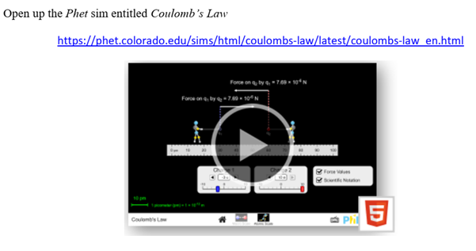

**2.**     Select the macro scale. As shown in figure below.



**3.**     Use the values for charges***Q1***and ***Q2***provided in “**Values of the Charges**”  of the next unit in below . Slide the bar to adjust the values of ***Q1***and ***Q2*** into the phet simulation software. keep them constant throughout as these will be controlled**.**

**4.**     Move the left charge, ***Q1***, as far left as possible and position the rule so that *0 cm* lines up with the center of ***Q1***.  Set the position of ***Q2***as close as possible to ***Q1***.

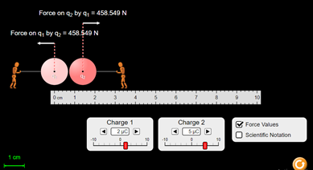

**5.**     Now change the distance ***r*** from the simulation scale and record the values of forces  between the charges***Q1***and ***Q2***and tabulatethe data in**table-1**.

**6.**       Use the second values for charges that are ***Q3***and ***Q4***provided in the “**Values of the Charges**”  unit. keep them constant throughout as these will be controlled.

**7.**     Find the distance***r***from the simulation by using the scale and record the force  between the charges***Q3***and ***Q4***shown in the simulation. Tabulate this data in **table-2.**

**8.**     Based on your data in above table-1 and table-2, **plot the** Electrostatic Force vs Distance curve using any software you like (specified softwares are recommended). **You must write your ID in each of your graphs.**

**9.** List and link for the graph plotting softwares

* [https://www.desmos.com/](https://www.google.com/url?q=https://www.desmos.com/&sa=D&source=editors&ust=1615199221470000&usg=AOvVaw0b_cLNVqdtCIbhQ88Rdonh)
* Link for the “Graph” software
* [https://www.padowan.dk/download/](https://www.google.com/url?q=https://www.padowan.dk/download/&sa=D&source=editors&ust=1615199221471000&usg=AOvVaw2FPzn_j7mMqCCbrAIt-hc5)
* Tutorial for plotting in Desmos : [https://youtu.be/-lIUNWVKnUY](https://www.google.com/url?q=https://youtu.be/-lIUNWVKnUY&sa=D&source=editors&ust=1615199221471000&usg=AOvVaw37ffYbld7LGdWne3PWUiB5)
* Tutorials for Graph Software: [Graph Software tutorials](https://www.google.com/url?q=https://www.youtube.com/playlist?list%3DPLWlcecaWx7bRckVJi2gxqMnC9Nrl8ig0f&sa=D&source=editors&ust=1615199221472000&usg=AOvVaw37u3O6SoVCPicPPz2GVWAX)

10. You must download the submission form which is a google doc. DO NOT try to edit the original document.

**11.**Draw  vs  graph that is you plot  along the  axis and   along the  axis. Find the **slope**  from the straight line you get.

**12.**     Draw the Electrostatic Force,  vs inverse square distance,  curve.  Find the **slope**  from the straight line you get.

**13.**       Using the slope of your graph (from **step 11**) along with the above ratio determine the value of the Coulomb's constant, *k*.

**14.**Calculation of**standard deviation** is a standard procedure for any kind of experiment and you **should** calculate it whenever possible.

**15.** Submit your lab report using the following submission form and link, which are given into the **Lab Report Submission Form and Upload your Lab Report unit**respectively.

**N. B.:**If you have any question regarding lab, you can post that into**#lab_all_sections**slack channel, by clicking the link below:

**https://app.slack.com/client/T01NFMYBWD6/C01P575CZ9V**